

**the Attractiveness of a Metropolitan Statistical Area for Millennials**

**Hao Jin**

**Minzhi Meng**

**Weikang Hu**

**Xingtao Liu**

**Yunliu Wu**

**Abstract**

This paper examines what factors attract millennials to a certain metropolitan area of the United States. We collected the data with the period from 2012 to 2017 from the American Community Survey. After aggregating individual-level yearly data by 259 metropolitan areas, we constructed our own dataset. Then we employed fixed effect model to investigate the effects of variables such as real GDP, education, nightlife entertainment, on millennials choice of location. Our study presents a new perspective that millennials take entertainment activities into consideration when they choose which MSA to live.

# **Introduction**

The locational preferences of young adults hold large consequences. According to government data analyzed by the Pew Research Center, millennials, defined as people born between the years 1981 and 2000, overtook the Baby Boomers as the largest adult population in the United States in 2019. The word “Youthification”, defined as the “influx of young adults into higher density” cities and neighborhoods, is used to explain the migration of young adults. In some ways, these neighborhoods with high youthification rates are “forever young,” where new cohorts of young people continue to move in as families and children cycle out in search of more space. Where young adults choose to live will have a significant and lasting impact on locations economically and culturally. Due to the great effect, numerous studies and researches have been conducted regarding where young adults want to live.

# **Literature Review & Theoretical Model**

* 1. **Literature Review**

The first paper is “Determinants of Residential Satisfaction: Ordered Logit vs. Regression Models”, published in 1999. This study reinvestigated the effects of housing, neighborhood, and household characteristics on individuals' satisfaction with both dwelling and neighborhood, to reconcile the inconsistencies in the previous research. The empirical analysis used data drawn from the American Housing Survey (AHS) and ordered logit models (OLM). The results showed that residential satisfaction is a complex construct, affected by a variety of environmental and socio‐demographic variables (Lu, 1999).

Mills and Hazarika examined young adult migration from non-metropolitan counties to either different non-metropolitan counties or metropolitan areas. The primary data source for the study is the NLSY, a unique panel of 12,686 individuals 14 to 21 years of age and the regional migration in 1979 that has been re-surveyed annually. The most significant characteristic is expected gains in initial earnings. This factor provides young adults with a great incentive to migrate from their non-metropolitan counties of origin. The decision to migrate is sensitive to the costs of migration, which, in turn, are correlated with paternal education and the local presence of extended family (Mills and Hazarika, 2001).

The thesis published in 2015, “Finding the ‘Generationed City’ The Form and Structure of Young Adult Settlement Patterns”, examined the present patterns in the residential geographies of young adults in major cities in Canada and the United States. It explained how the differences and similarities in young adult residential patterns across metropolitan regions were shaped by the wider context of post-Fordist economic restructuring, urban planning, and the neoliberal remaking of the city. The research found that generational requirements for residence would change greatly. This paper suggested that young adults were responsive to dense housing form, urban amenities and transit provision in both central areas and extending into suburban reaches. In major metropolitan regions in the United States and Canada young adults live centrally (Walter-Joseph, 2015)

Smith and Sage published a research paper 2014 about young adult migration. The paper focused on a more encompassing perspective of the regional migration patterns of young adults (16–24), extending studies of labor-motivated graduate migration. The paper argued that leading constituent of demographic and population changes in society is due to the migration of young adults. They calculated changes at the local authority level by comparing ‘snap-shot’ cross-sections of GP registers, taken on the 31st of each year (from the NHS Central Register – NHSCR). A move was identified by matching each patient’s NHS number between these cross-sections and checking for changes to the postcode indicating that the individual has moved to a different local authority (adjusted for entering and graduating migration). (Smith and Sage, 2014)

Another paper looked at whether Millennial first-time homebuyers are more likely to buy homes near city centers than their counterparts in Generation X. In 2018, Millennial First-Time Homebuyers and Location Choice used a logistic regression model controlling for age and generation with controlled for income, credit score, car ownership, mortgage size, mortgage payment, and student-debt level. The data used was a random sample of individual credit records data to examine first-time mortgaged homebuyers from 2000 to 2016 in the fifty largest US cities. The result showed that the odds of Millennials buying near city centers are 21 percent higher than for Generation X. This suggests that as Millennials purchase homes, they do not move to the suburbs at the same rate as Generation X. (Raymond, Dill and Lee, 2018)

The article published in 2018, Are Millennials Coming to Town? Residential Location Choice of Young Adults provided a detailed analysis of the past, current, and future geographic population distribution, focusing on young adults. This article empirically examined the generational residential patterns using a multinomial logistic regression, suggesting the generational characteristics of Millennials, at least partially, explained their inclination to choose the city center over suburbs. Using distance from CBD as the dependent variable, the model used independent variables as age, year FE, age * year FEs, gender, race, education, employment, etc. The results indicated that ongoing demographic shifts might contribute to more population growth in urban centers over the next two decades. (Lee, 2018)

The latest paper was published in 2019. Urban revival by Millennials? Intraurban net migration patterns of young adults, 1980–2010, investigates net migration of Millennials in the top 20 urbanized areas in the United States on a neighborhood scale. They found that the factors drawing people to the city differ for various generations. The youngest group, those aged 20 to 24, consistently showed the strongest preference for amenities such as the density of retail, entertainment, recreation, and food-services employment. The attract of amenities for slightly older adults, aged 25 to 34, increased significantly over time, so the study concluded that amenities did not matter in the 1990s, yet came to matter significantly in the 2000s. Another attractive factor is access to transit, which matters most for those aged 25-34 and 35-44 is access to transit. This is likely because transit matters more for how these groups commute to work. The descriptive and regression analyses in the paper show that Generation Xers and Millennials were more likely to net migrate into central locations and less aversive to high density at their young ages than late boomers were in the 1980s. (late Gen Xers and older Millennials) than in the 1990s (early Gen Xers). (Leeand Shubho, 2019)

1. **Data**
   1. **Data Resources**

Our data are drawn from two principal sources. The first is the American Community Survey (ACS) database, which appears in the Integrated Public Use Microdata Series (IPUMS USA). IPUMS consists of more than fifty high-precision samples of the American population drawn from fifteen federal censuses and from the American Community Surveys of 2000 to present. ACS Census data are based on surveys of occupations, educational attainment, veterans, housing prices and so on by U.S. residents. Every year, the U.S. Census Bureau contacts over 3.5 million households across the country to participate in the American Community Survey. The second major source of information is U.S. Bureau of Economic Analysis. The database produces economic statistics that enable government and business decision-makers, researchers, and the American public to follow and understand the performance of the nation’s economy.

## **Data Description**

We derive most of our variables from individual level in ACS Census by aggregating the micro data together and then taking the average value for each of them within each MSA. We also include some macro data for each MSA like GDP level and price level directly from BEA.

After tedious transformation and calculation processes, we construct a dataset with 12 variables for 259 metropolitan areas of 6 years (2012-2017), and thus there are 1548 observations in total. All variables in our model have a straightforward interpretation as we define (see Table 1), each reflecting a certain characteristic in every metropolitan area.

Table 1

|  |  |  |
| --- | --- | --- |
| **Variable Name** | **Transformation** | **Interpretation** |
| **Ratio**  **(dependent variable)** | $$\frac{number of people between 25-29}{number of people between 13-17}$$ | whether millennials move in (ratio>1) or out (ratio<1) of this MSA |
| **Real-GDP** | $$\frac{Nominal GDP}{CPI}$$ (2009 as base year) | real total GDP (2009 as base year) in this MSA |
| **Education** | $$\frac{number of 25-29 with BA degree}{total number of 25-29}$$ | the percentage of millennials with BA degree in this MSA |
| **Real-Income** | $$\frac{average income of 25-29 in MSAi}{CPI}$$ (2009 as base year) | average income of people between 25-29 divided by the regional price parities in this MSA |
| **Employment** | $$\frac{number of 25-29 employed}{total number of 25-29}$$ | the employment rate of 25-29 in this MSA |
| **Density** | $$\frac{sample population in {MSA}_{i}}{land area of MSA i}$$ | the sample density of people in this MSA |
| **Immigration** | $$\frac{ number of 25-29 born overseas}{total number of 25-29}$$ | the percentage of people between 25-29 who were born in foreign countries in this MSA |
| **Bartender** | $$\frac{number of bartendern }{overall sample population}$$ | the percentage of people worked as bartender in this MSA |
| **Children** | $$\frac{number of age<12}{overall sample population}$$ | the percentage of children in this MSA |
| **College** | $$\frac{number of 18-22 in college}{total number of 18-22}$$ | the proportion of people between 18-22 who is in college or with a BA degree |
| **Transportation** | average transportation time per day in this MSA | average transportation time per day in this MSA |
| **Workhours** | average of hours of work per week | the average hours of work per week for people between 25-29 in this MSA |

All the variables in our model is for sample measurement

We plot our variables in 2017 onto the map and here are some summary of the variables.

Figure 1 the 2017 Results of Variable ratio

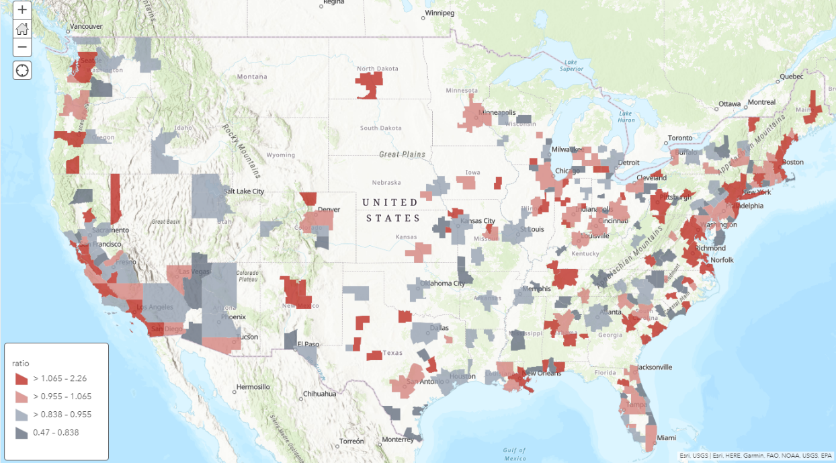

From this figure, we find that metropolitans near the country border have larger ratios. Besides, large metropolitans, like Boston, Los Angeles, Seattle and state’s capitals in the middle of US, seem to have a higher proportion of millennials.

Figure 2 the 2017 Results of Variable employment

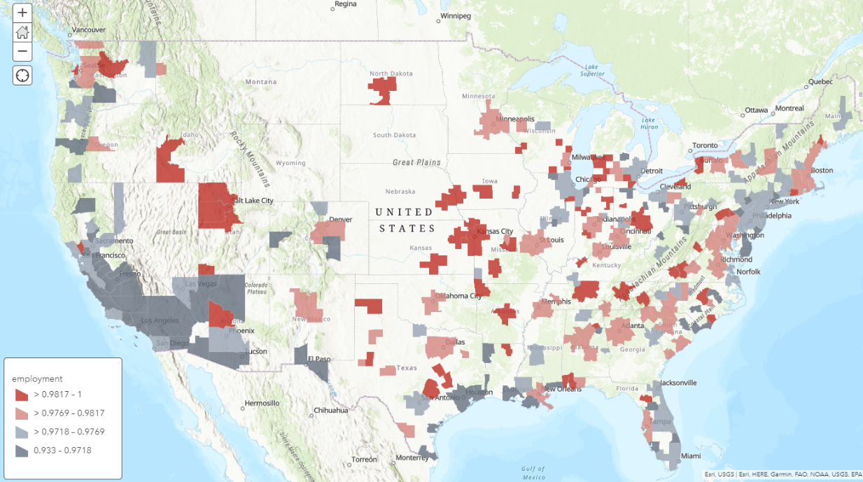

Employment rates are lower in those largest metropolitan areas like New York City and Los Angeles. However, most of metropolitan areas in the middle of US tend to have a higher rate of employment.

From this figure, we find that metropolitans near the country border have larger ratios. Besides, large metropolitans, like Boston, Los Angeles, Seattle and state’s capitals in the middle of US, seem to have a higher proportion of millennials

Figure 3 the 2017 Results of Variable employment

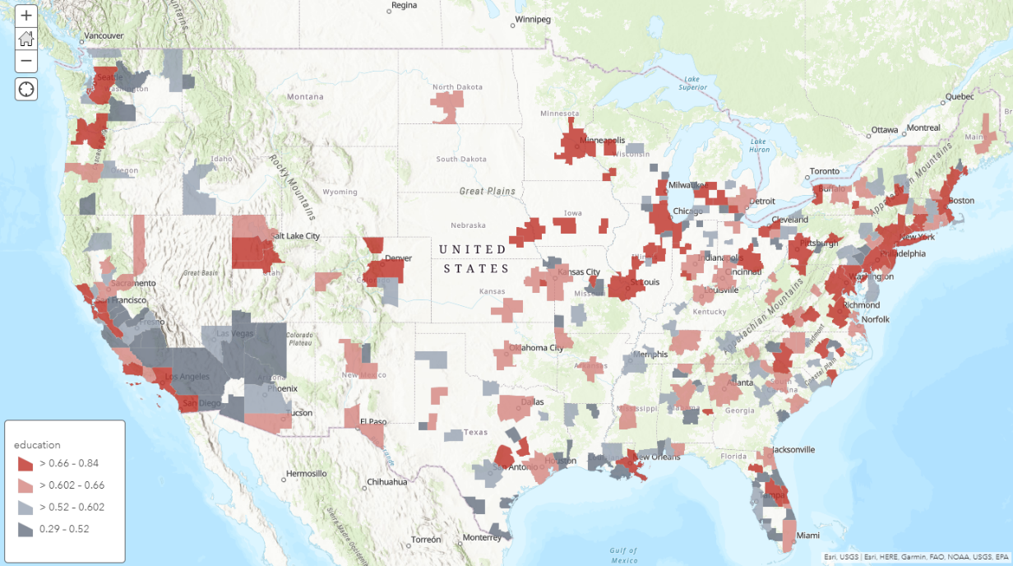

For education, people in large metropolitan areas usually have higher education levels.

Figure 4 the 2017 Results of Variable real income

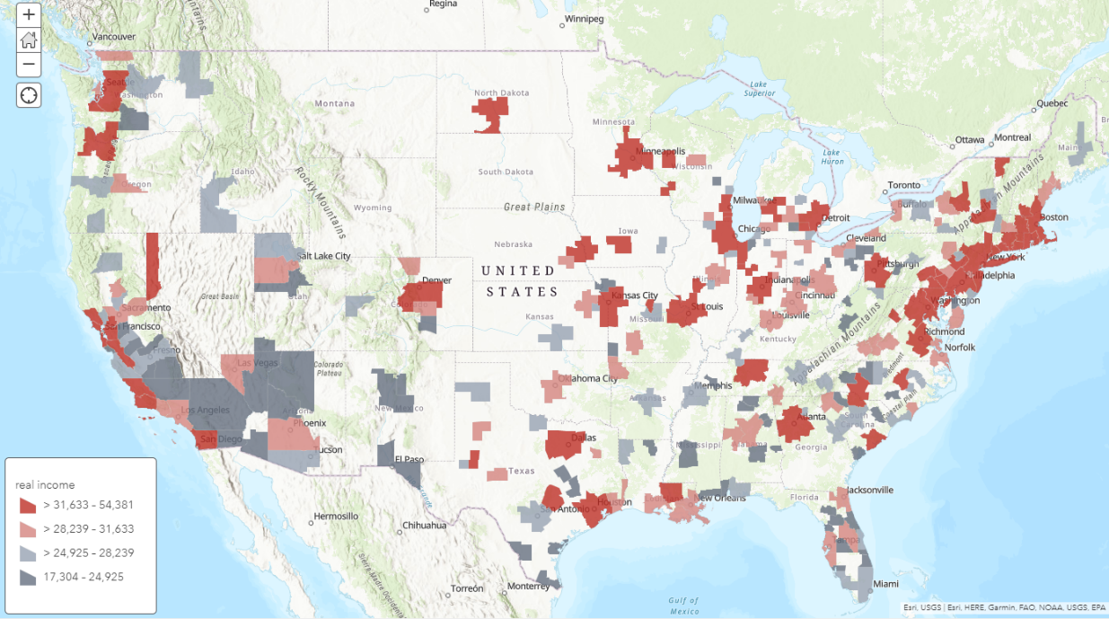

Figure 5 the 2017 Results of Variable real GDP

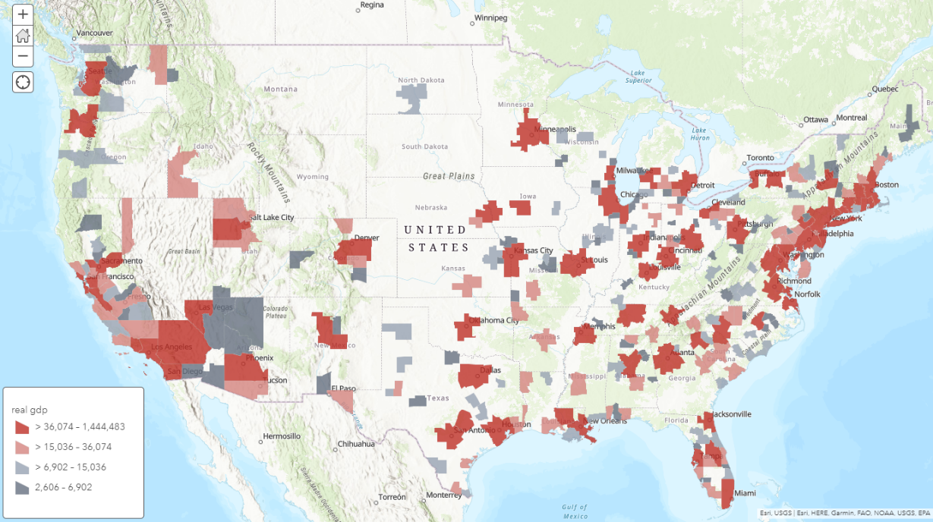

For both real GDP and real income, large MSAs have higher ratios.

Figure 6 the 2017 Results of Variable real immigration

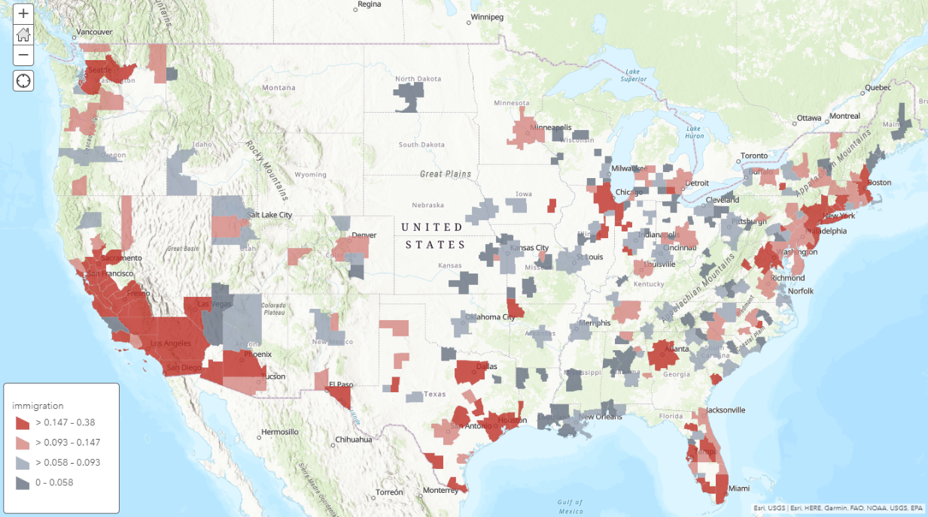

Apparently, MSAs near the border have a higher ratio of immigrants.

Figure 7 the 2017 Results of Variable bartender

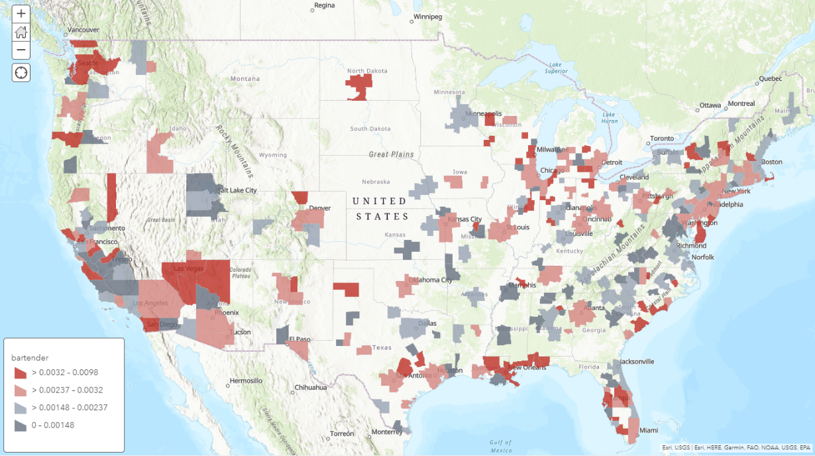

For bartender, which is a measure of nightlife entertainment, we find the ratio is higher large cities and for those MSAs famous for entertainment like Las Vegas and Atlantic City.

Figure 8 the 2017 Results of Variable hourswork

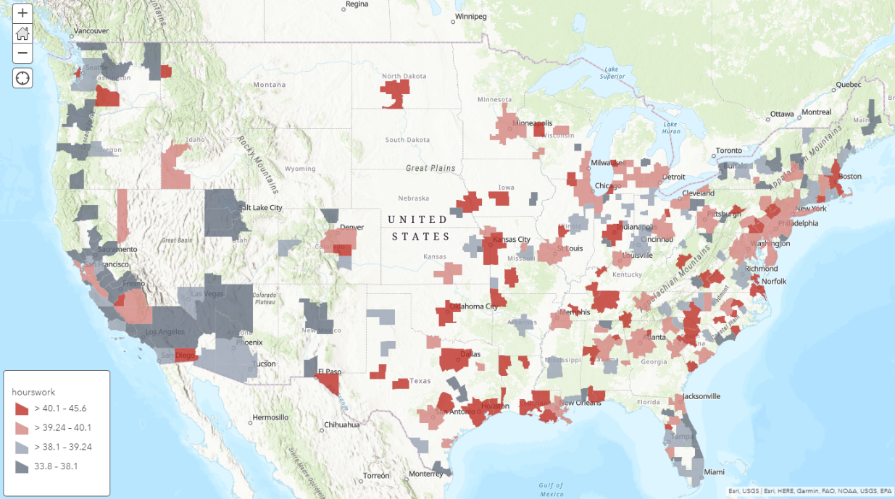

Millennials in the east and mid of US seem to work more than the west.

Based on the theory above, the dependent variable we construct is, for a particular metropolitan area and year, the ratio of popularity, which is, the number of people with age ranging from 25 to 29 divided by the equivalent observation for all ages. This ratio is used to measure whether millennials want to move in or out of this metropolitan area. If young adults’ inflow is larger than outflow, the ratio will be greater than 1, which means that this metropolitan area seems to attract millennials.

Independent variables capture various characteristic indices of the metropolitan area. Variable real GDP is used to measure the economic size of the MSA. The difficulty of finding a job and average income attainment might be two strong considerations when young people choose a metropolitan, thus we include variable employment and real-income. Education measures how education level in this MSA attracts millennials. Besides, crowdedness, which in our model is the population density, can also affect millennial’s’ choices of living. The ratio of immigrants can also be a factor. In our discussion, the more open a metropolitan area is to immigrants, the more willingness young people have to live there. We also include the entertainment variable bartender as the indicator of the colorfulness of nightlife in those metropolitan areas. Besides, the proportion of children among population needs to be included as control variables because when proportion of children is higher in that MSA, the proportion of young adults is also higher. For the same consideration, we also include college as a control variable. College students tend to stay in that MSA after graduation. Besides, we also include transportation and hours of work to study whether the commuting time and workload for young people would make a difference in their propensity of the metropolitan area.

# **Empirical Model**

* 1. **Model Construction**

We planed to use the fixed or random effect model in panel data to estimate what factors of MSA attract the millennials. The general form is of our theoretical model is as below,

${ratio}_{it}=α_{i}+β_{0}+β_{i}x_{it}+ε_{it}$, where

${ratio}_{it}$: the ratio of population between 25-29 over the population between 13-17 in each

MSA, which can measure if young people prefer to move into this MSA or move out from this MSA

$α_{i}$: time-invariant individual-specific effect

$β_{0}$: the intercept

$x_{it}$: independent variable

$ε_{it}$: error term

At the beginning of the first, we included variables real GDP, education, real income and employment as explanatory variables into our model (Model 1). These variables reflect the fundamental characteristics of a metropolitan areas. We expected all the factors have the positive effect to the dependent variable.

${ratio}_{it}=α_{i}+β_{0}+β_{1}{real_gdp}_{it}+β_{2}{educ}_{it}+β_{3}{real_income}_{it}+β_{4}{employment}_{it}+ε_{it}$ (Model 1)

We then added density and immigration variables into our model (Model 2) as density is a measurement of crowdedness, and immigration captures the friendliness of the metropolitan statistical area to its immigrants.

${ratio}_{it}=α_{i}+β_{0}+β_{1}{real_gdp}_{it}+β_{2}{educ}_{it}+β_{3}{real_income}_{it}+β_{4}{employment}_{it}+{β_{5}{density}_{it}+β_{6}{immigration}_{it}+ε}_{it}$ (Model 2)

In Model 3, the entertainment indicator was included based on Model 1 and Model 2. The new variable here is bartender, which is used for measuring nightlife activities in a metropolitan statistical area. This is the most interesting factor in our model, as it hasn’t been studied by previous papers. It makes sense in that at the age of 25 to 29, people evaluate nightlife entertainment as a very important part for their location choice. As young adults are burdened with stressful work issues during the daily work, they need some entertainment places for refreshment such as bars and night clubs. Those places can also provide a space for young people to network, and that’s why they are popular sites attract young people to hit.

${ratio}_{it}=α_{i}+β_{0}+β_{1}{real_gdp}_{it}+β_{2}{educ}_{it}+β_{3}{real_income}_{it}+β_{4}{employment}_{it}+{β_{5}{density}_{it}+β_{6}{immigration}_{it}+β_{7}{bartender}_{it}+ε}_{it}$ (Model 3)

We then added another two interesting factors, transportation and workhours, to measure the work situations for each metropolitan statistical area (Model 4). As the MSA has shorter average travel time from home to workplace as well as the shorter average weekly work hours, we expect that young people are more willing to move into that metropolitan area.

As you can see from Model 4, we also include college and children as our control variables because we think the population of children would have an impact on the population of our target age group by nature, and as college students tend to stay at the college-based metropolitan to work or intern either in or after school, we are reasonable to believe that higher college students yield to higher population in age of 25-29. In order to remove the effects of these two variables, we put them into our model as control variables.

${ratio}_{it}=α_{i}+β_{0}+β_{1}{real_gdp}_{it}+β_{2}{educ}_{it}+β_{3}{real_income}_{it}+β_{4}{employment}_{it}+{β_{5}{density}_{it}+β_{6}{immigration}_{it}+β_{7}{bartender}_{it}+β_{8}{children}_{it}+β_{9}{college}_{it}+β_{9}{transportation}_{it}+β_{10}{hourswork}_{it}+ε}_{it}$ (Model 4)

## **Hausman Test**

We estimate each model by using regression with fixed effect and random effect, and then run Hausman test with null hypothesis that there is no difference between random effect coefficient and fixed effect coefficient. If we failed to reject the null hypothesis, we will estimate our model by using random effect model, otherwise, we will estimate our model by using fixed effect model.

# **Regression Results and Interpretation**

We have fitted our theoretical model equations using fixed effect (for each MSA) panel model (see Table 2).

|  |  |  |  |  |
| --- | --- | --- | --- | --- |
|  |  | **Table 2** |  |  |
|  | (1) | (2) | (3) | (4) |
| VARIABLES | ratio | ratio | ratio | ratio |
|  |  |  |  |  |
| real GDP | 1.41e-06** | 1.90e-06*** | 1.87e-06*** | 1.96e-06*** |
|  | (5.83e-07) | (5.90e-07) | (5.90e-07) | (5.95e-07) |
| educ | 0.218*** | 0.212*** | 0.217*** | 0.210** |
|  | (0.0812) | (0.0809) | (0.0807) | (0.0828) |
| real income | 0.000326** | 0.000362*** | 0.000386*** | 0.000385*** |
|  | (0.000135) | (0.000135) | (0.000135) | (0.000146) |
| employment | 0.832** | 1.043*** | 1.013*** | 1.108*** |
|  | (0.342) | (0.343) | (0.343) | (0.352) |
| density |  | -0.470*** | -0.477*** | -0.520*** |
|  |  | (0.119) | (0.119) | (0.123) |
| immigration |  | 0.254** | 0.248** | 0.234* |
|  |  | (0.125) | (0.125) | (0.125) |
| bartender |  |  | 5.921** | 5.741** |
|  |  |  | (2.538) | (2.546) |
| children |  |  |  | 0.698 |
|  |  |  |  | (0.442) |
| college |  |  |  | 0.0876 |
|  |  |  |  | (0.0941) |
| transportation |  |  |  | -0.000104 |
|  |  |  |  | -0.0016 |
| hours work |  |  |  | 0.00155 |
|  |  |  |  | (0.00310) |
| Constant | -0.150 | 3.500*** | 3.564*** | 3.630*** |
|  | (0.316) | (0.999) | (0.998) | (1.019) |
|  |  |  |  |  |
| Observations | 1,548 | 1,548 | 1,548 | 1,548 |
| R-squared | 0.039 | 0.053 | 0.057 | 0.060 |
| Number of MET2013 | 258 | 258 | 258 | 258 |
| Standard errors in parentheses | |  |  |  |
| *** p<0.01, ** p<0.05, * p<0.1 | |  |  |  |
|  |  |  |  |  |

Results of Hausman test:

Based on the result of Hausman test, the p-value is zero for all four models, so there are some correlations between the individual specific factors and independent variables. The fixed effect is better.

**Table 3**

|  |  |  |  |  |
| --- | --- | --- | --- | --- |
| **Hausman** | **Model 1** | **Model 2** | **Model 3** | **Model 4** |
| **Chi-Square** | 34.08 | 48.92 | 53.47 | 139.69 |
| **p-value** | 0.0000 | 0.0000 | 0.0000 | 0.0000 |

In our last model, all the coefficients are statistically significant except the transportation and hours of work, which means the travel time to work and average working hour per week have no effect on the choice of the millennials. The real GDP has significant positive effects on attracting the millennials, suggesting the when real GDP increases by 10 billion, the percentage of young people moving into this metropolitan area will increase by 1.92%. This is reasonable as people prefer to live in the big and prosperous areas. Meanwhile, there is some positive linkages between education and the percentage of young people. When the percentage of millennials with bachelor degree increases by 1%, the percentage of young people moving into this area will increase by 0.21%. The higher real income and employment rate also attract more young people to this area, which can be interpreted as the young people are moving to areas with higher purchasing power and more working opportunities. The density of people in a metropolitan has a negative effect on the ratio. A 1% increase in population density of a metropolitan will result in a 0.5% decrease of young people ratio. The immigration also has positive effect on attracting the millennials, as the percentage of foreign-born millennials increase by 1%, 0.25% more young people will be attracted. Finally, the percentage of people worked as bartender also have positive effects, and it’s a proxy of nightlife and entertainment. With a 1% increase in bartender number, the ratio will increase by 5%.

Overall, large metropolitan areas seem to be attractive for young people. (GDP level can be a measure of the size of MSA). Young people also tend to move to metropolitan areas where there are higher proportion of educated people, where they can earn more money, where they can easier to find a job. Places with less population density attract more millennials where they can get more room of themselves. Colorful and relaxing nightlife and entertainment lure more young people. Places with more diversified races seem to attract young people.

After getting the regression results, we also predicted the fitted value of our dependent variable using the 4th model. These two figures show the fitted value and residuals of our regression. Apparently, the predicted values are good fits for our dependent variable except for some outliers. And this table picked some of the best fitted and worst fitted values. Most big metropolitan areas fit well in this model while some small metropolitan areas are the outliers. For these outliers, there may be some special factors that we didn’t capture.

**Graph 1 Graph 2**



**Table 4**

|  |  |  |  |
| --- | --- | --- | --- |
| **Best fitted MSAs** | **Residual** | **Worst fitted MSAs** | **Residual** |
| **New York-Newark-Jersey City** | -0.039 | **Ithaca** | -0.286 |
| **Chicago-Naperville-Elgin** | -0.004 | **Austin-Round Rock** | -0.153 |
| **Los Angeles-Long Beach-Anaheim** | -0.043 | **Atlantic City-Hammonton** | -0.155 |
| **Miami-Fort Lauderdale-West Palm Beach** | 0.006 | **Wilmington, NC** | 0.172 |
| **Washington-Arlington-Alexandria** | 0.023 | **Punta Gorda, FL** | 0.244 |

# **Conclusion**

By overtaking the baby boomers, millennials become the largest adult population of US and studying millennials’ location choice will help government understand young adult. The purpose of this study is to analyze what factors of metropolitan statistical areas attract millennials. By aggregating US census data, creating a ratio of the number of people with age ranging from 25 to 29 to the number of people with age ranging from 13-17 and running several regressions, our study shows that if a metropolitan statistical area has a larger scale, higher employment, more educated people, lower population density and more nightlife entertainments, it will become a popular preferable place for millennials.

The most important contribution of our paper is taking nightlife entertainment variable into consideration. By using the ratio of bartenders as an explanatory variable, the result shows that young adults prefer to live in an MSA area that has more nightlife activities. Hence, if a city wants to attract more young labor force in the future, building more bars or night clubs may become a valid method.

Our study has provided a unique look at Millennials’ location preference and there are many other areas are opened for further research. Since US census data and economics macro data could not provide information about a metropolitan statistical area’s crime rate and political climate, more study can be conducted to see if those variables are correlated with millennials’ location choice. Furthermore, it will be interesting to see if having friendly neighbors, community engagement or better wealth condition can help the metropolitan statistical area attracts more millennials.

**Reference**

Blumenberg, E., Ralph, K., Smart, M. and Taylor, B. (2016). Who knows about kids these

days? Analyzing the determinants of youth and adult mobility in the U.S. between 1990

and 2009. Transportation Research Part A: Policy and Practice, 93, pp.39-54.

Couture, V. and Handbury, J. (2017). Urban Revival in America, 2000 to 2010.

Deka, D. (2018). Are millennials moving to more urbanized and transit-oriented counties? Journal of Transport and Land Use, 11(1).

Frankel, Jeffrey, and Andrew Rose, 1996, “Currency Crashes in Emerging Markets: AnEmpirical

Treatment,” Journal of International Economics, Vol. 41, pp. 351-66.

Jacobsen, J.P. (1999) Labor force participation. The Quarterly Review of Economics and

Finance 39(5): 597–610.

Laeven, Luc, and Fabian Valencia, 2008, “The Use of Blanket Guarantees in Banking Crises.”

Mimeo. (Washington: International Monetary Fund).

Laeven, Luc, and Fabian Valencia, 2018. "Systemic Banking Crises Revisited," IMF Working

Papers 18/206, International Monetary Fund.

Lee, H. (2018). Are Millennials Coming to Town? Residential Location Choice of Young

Adults. Urban Affairs Review, p.107808741878766.

Lee, Y., Lee, B. and Shubho, M. (2019). Urban revival by Millennials? Intraurban net migration

patterns of young adults, 1980–2010. Journal of Regional Science, 59(3), pp.538-566.

Lu, M. (1999). Determinants of Residential Satisfaction: Ordered Logit vs. Regression Models.

Growth and Change, 30(2), pp.264-287.

Mills, B. and Hazarika, G. (2001). The Migration of Young Adults from Non-Metropolitan

Counties. American Journal of Agricultural Economics, 83(2), pp.329-340.

Raymond, E., Dill, J. and Lee, Y. (2018). Millennial First-Time Homebuyers and Location

Choice. Journal of Planning Education and Research, pp.0739456X1880775.

Signorelli, Marcello, Misbah Choudhry, and Enrico Marelli. "The impact of financial

crises on female labour." The European Journal of Development Research 24.3 (2012):

413-433.

Smith, D. and Sage, J. (2014). The regional migration of young adults in England and Wales

(2002, 2008): a ‘conveyor-belt’ of population redistribution?. Children's Geographies,

12(1), pp.102-117.

Walter-Joseph, R. (2015). Finding the “Generationed City”: The Form and Structure of Young

Adult Settlement Patterns. [online] Hdl.handle.net. Available at:

http://hdl.handle.net/10012/9275 [Accessed 8 Dec. 2019].